Test Case: tc001_SPX_Dev5_Crear_Requisicion_Spot_Tipo_Cobro_CC
Step 1 - Enter username and password and click to button Enter : Credentials Entered
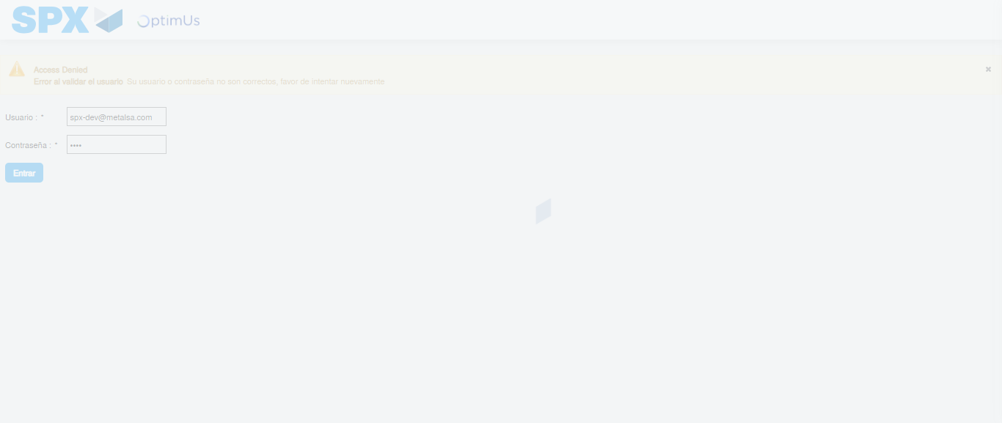Image file-name: QC_Testing-tc001_SPX_Dev5_Crear_Requisicion_Spot_Tipo_Cobro_CC-1790177008620

Step 2 - Select to UEN and Access to Spot Buy Requisitions : UEN Correctly selected and Correct access
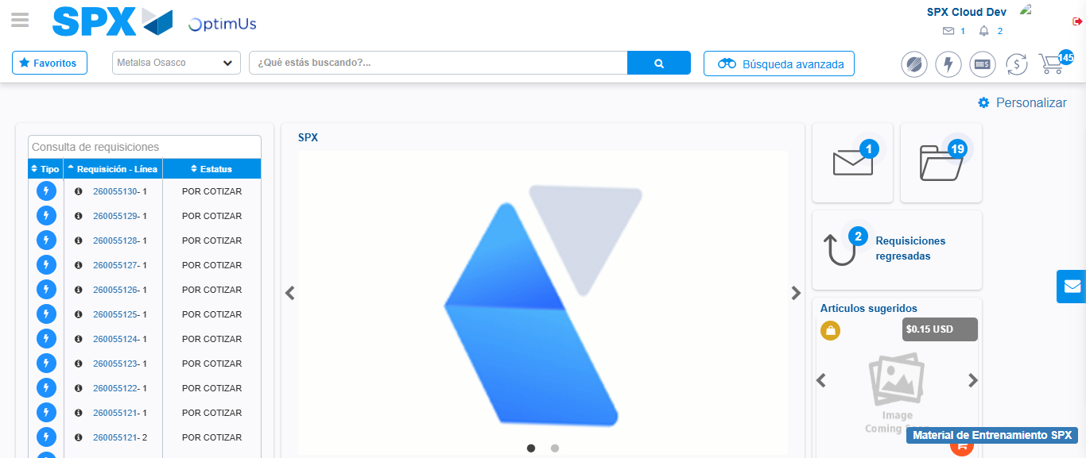Image file-name: QC_Testing-tc001_SPX_Dev5_Crear_Requisicion_Spot_Tipo_Cobro_CC-1790177032807

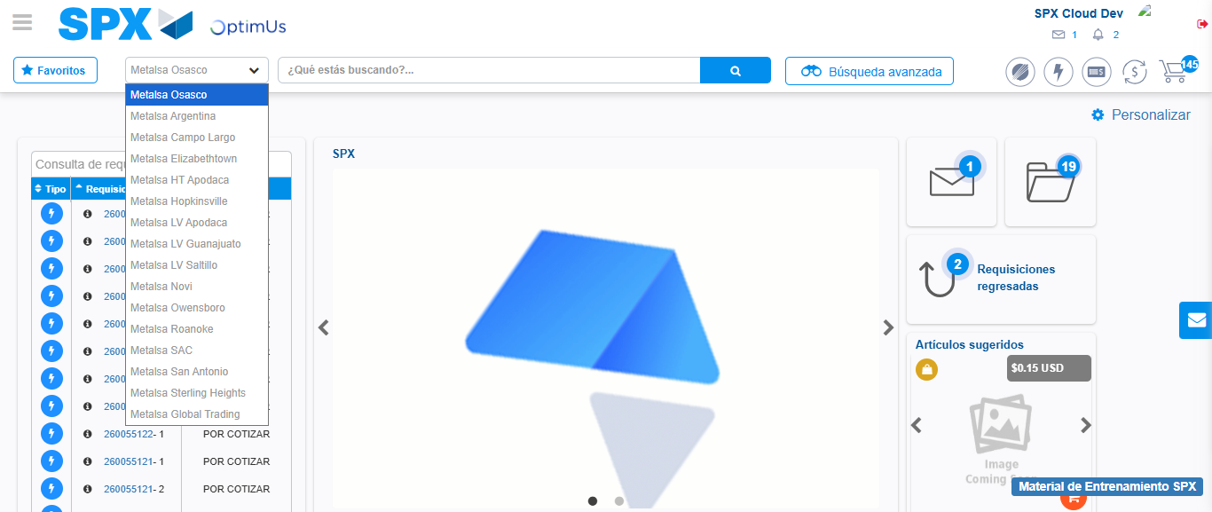Image file-name: QC_Testing-tc001_SPX_Dev5_Crear_Requisicion_Spot_Tipo_Cobro_CC-1790177033554

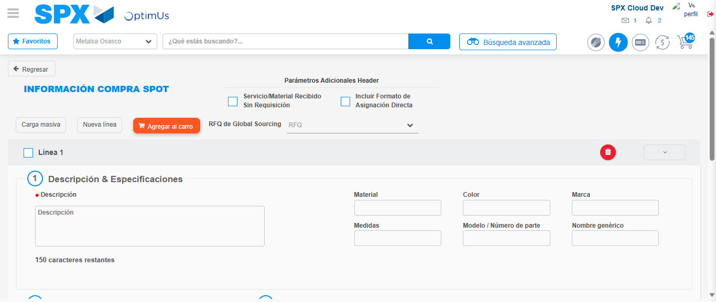Image file-name: QC_Testing-tc001_SPX_Dev5_Crear_Requisicion_Spot_Tipo_Cobro_CC-1790177039124

Step 3 - Data Capture Spot Buy Requisition : Data captured correctly
Image file-name: QC_Testing-tc001_SPX_Dev5_Crear_Requisicion_Spot_Tipo_Cobro_CC-1790177039412

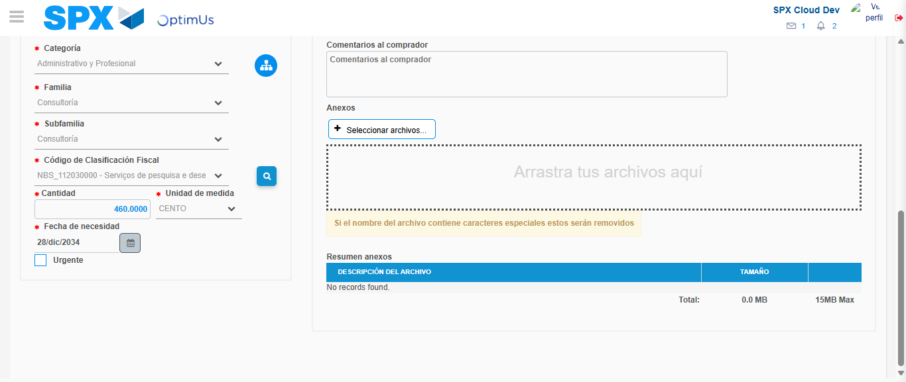Image file-name: QC_Testing-tc001_SPX_Dev5_Crear_Requisicion_Spot_Tipo_Cobro_CC-1790177057724

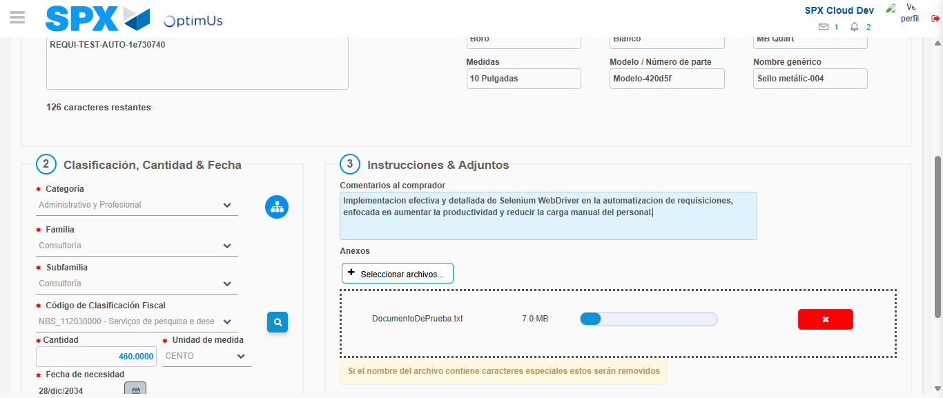Image file-name: QC_Testing-tc001_SPX_Dev5_Crear_Requisicion_Spot_Tipo_Cobro_CC-1790177058600

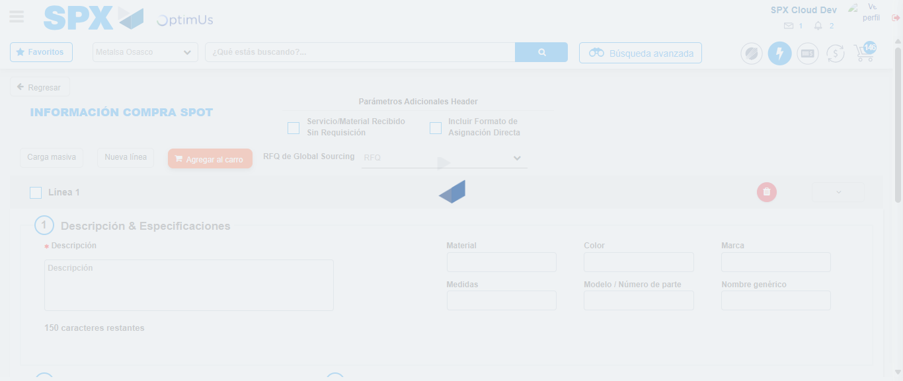Image file-name: QC_Testing-tc001_SPX_Dev5_Crear_Requisicion_Spot_Tipo_Cobro_CC-1790177059572

Step 7 - Return to Main Page SPX : Return to Main Page SPX
Image file-name: QC_Testing-tc001_SPX_Dev5_Crear_Requisicion_Spot_Tipo_Cobro_CC-1790177032807

Image file-name: QC_Testing-tc001_SPX_Dev5_Crear_Requisicion_Spot_Tipo_Cobro_CC-1790177033554

Image file-name: QC_Testing-tc001_SPX_Dev5_Crear_Requisicion_Spot_Tipo_Cobro_CC-1790177039124

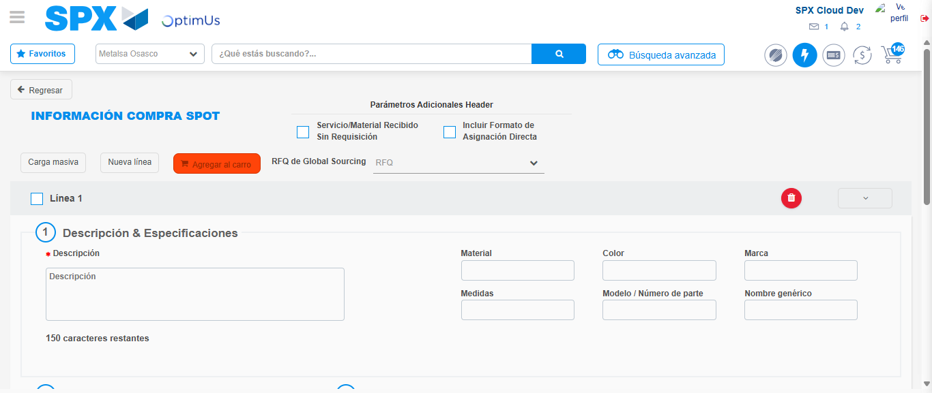Image file-name: QC_Testing-tc001_SPX_Dev5_Crear_Requisicion_Spot_Tipo_Cobro_CC-1790177061830

Image file-name: QC_Testing-tc001_SPX_Dev5_Crear_Requisicion_Spot_Tipo_Cobro_CC-1790177062041

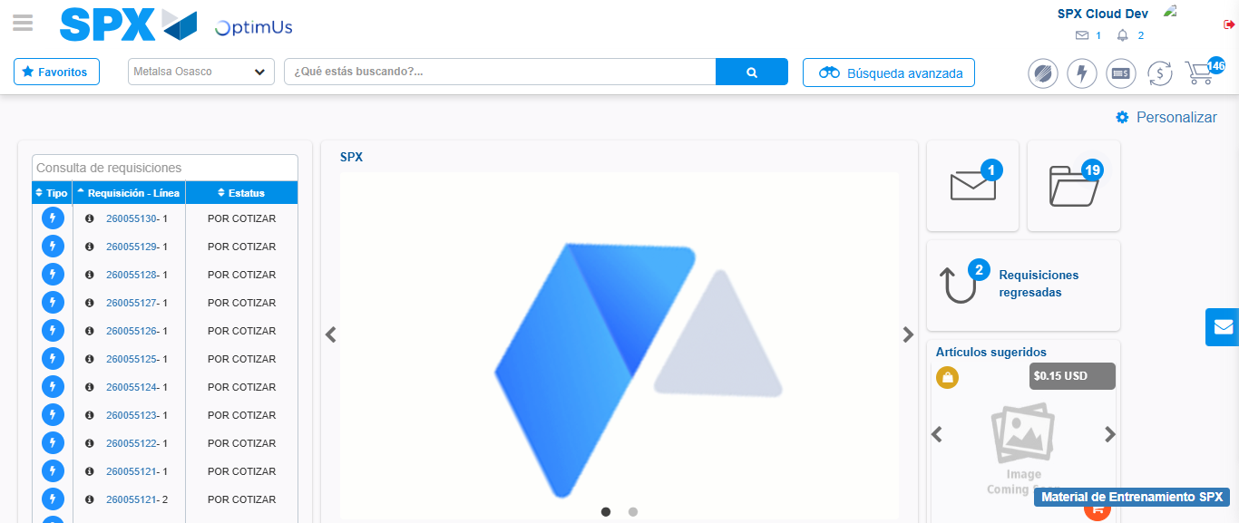Image file-name: QC_Testing-tc001_SPX_Dev5_Crear_Requisicion_Spot_Tipo_Cobro_CC-1790177083558

Step 8 - Log Out : Log Out SPX
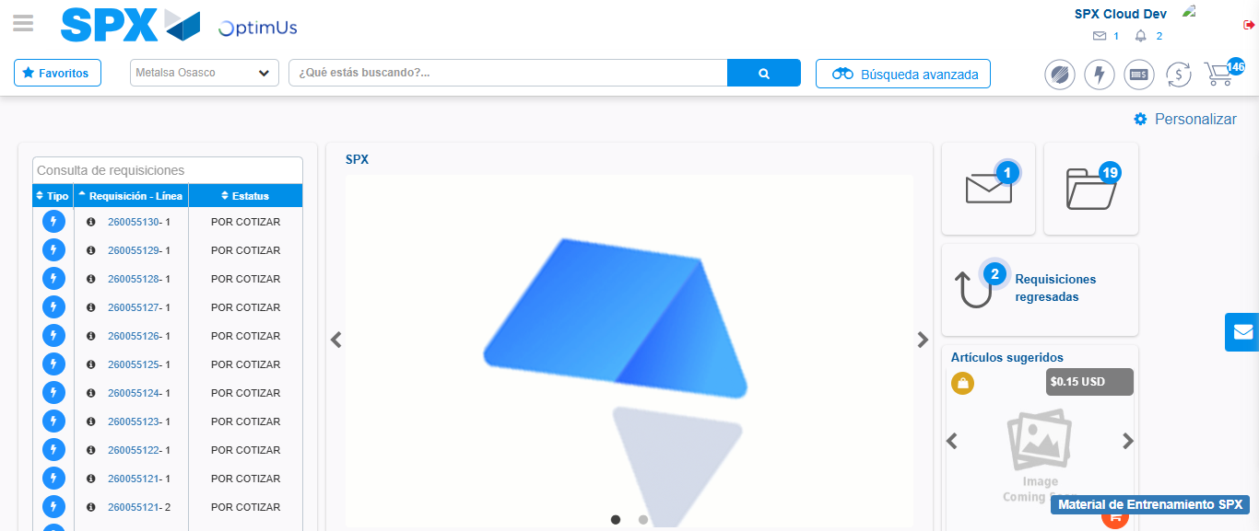Image file-name: QC_Testing-tc001_SPX_Dev5_Crear_Requisicion_Spot_Tipo_Cobro_CC-1790177083955

